Areas of expertise:
- EMDR Certified Therapist (EMDRIA)
- Trauma
- Complex trauma
- Older adults
- Caregiving
- Dementia
- Grief
Licensure:
Licensed Clinical Social Worker,
Texas License Number 69390

Education:
Master of Social Work, Baylor University
M.A. in Physics, Harvard University
B.A. in Physics, Princeton University

Professional certifications:
EMDR Certified Therapist (EMDRIA), EMDR International Association
Certified Practitioner of the MBTI (personality assessment), The Myers & Briggs Foundation
PAC Certified Independent Consultant (dementia care), Positive Approach to Care
Gottman Level I Trained (couples therapy), Gottman Institute
Professional affiliations:
Member, National Association of Social Workers
Member, EMDRIA (EMDR International Association)

In person or virtual:
Therapy sessions are offered in person, or online, as the client chooses

Location:
1000 Gattis School Road, Suite 930
Round Rock, TX 78664-2571

Teletherapy:
via secure, HIPAA-compliant system

Hours:
By appointment
Tuesday-Saturday 8:00 AM-6:00 PM

Fees:
Therapy session (53 minutes): $150
Initial evaluation (90 minutes): $175
Discounts available for private-pay clients
Sliding scale available for qualified clients

FREE consultations:
Schedule a free, 15-minute phone consultation

Contact Catherine Stansbury:
Phone (direct line):
(737) 289-0055
Email:
catherine@stansburycounseling.com

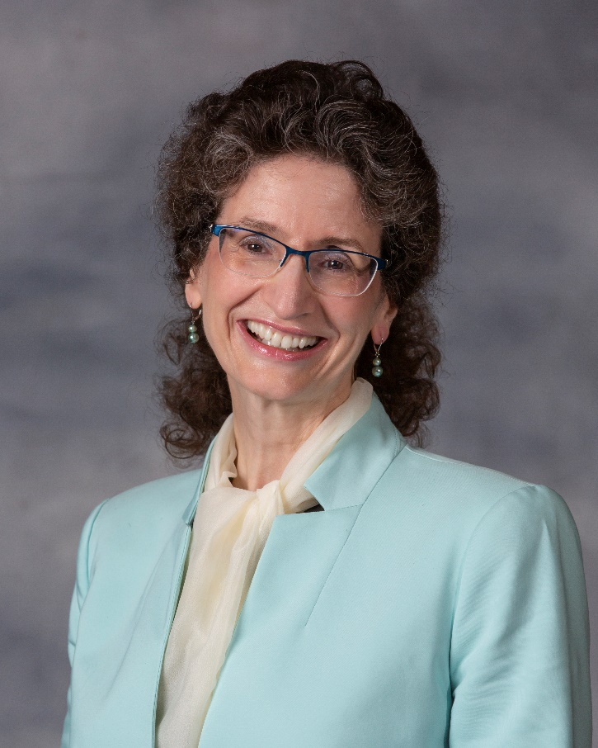

Catherine C. Stansbury, LCSW

Thank you for considering choosing me as your social worker. I appreciate your courage in seeking counseling. It takes courage to invite someone to understand your life. You alone are the expert in your own life. My pledge is to provide a safe space where you can explore your thoughts, behaviors, and feelings; where you can formulate your goals; where you can figure out how to pursue your goals; and where you can set your own pace. I know that counseling can lead to healing, growth, and transformation. I hope that you will invite me to share your journey with you.
I specialize in trauma therapy for individual adults of ages 18-100. It is my honor and my joy to work with persons who have carried terrible burdens of trauma and pain for many years; and to help them unload those burdens, and find healing, hope, and peace.
My favorite form of therapy is Eye Movement Desensitization and Reprocessing (EMDR). I am an EMDR Certified Therapist (EMDRIA) who is pursuing advanced training in treating complex trauma. This means that I find it a special privilege to work with clients who have experienced many distressing events. EMDR is a solidly-researched psychotherapy approach that helps people recover from trauma, PTSD, anxiety, depression, panic disorders, addiction, and many other difficulties in living. EMDR is a gentle, but powerful, way to assist the brain’s natural healing process.
In addition to EMDR, I like to share with my clients various other approaches, according to their needs and preferences: cognitive behavioral therapy (CBT); ego state therapy; the Myers-Briggs Type Indicator (MBTI); motivational interviewing (MI); Rogerian (person-centered) therapy; and logotherapy. If you request it, I also offer faith-integrated counseling, Christian counseling, or Catholic counseling, in which my goal is to help you draw strength from your own beliefs and spirituality.
I welcome the privilege of serving clients from diverse backgrounds, cultures, outlooks, and worldviews. I ask each client to teach me about their beliefs and life experiences.
Being a caregiver is what led me to become a social worker. I am trained in working with older adults, caregivers, dementia, and grief.
It would be an honor to work with you in this part of your life journey, and to assist in your healing, growth, and transformation.
Catherine Stansbury

